Donation Approval

Woodmen Life PS 6429 has been a generous sponsor of our Senior Center for many years. Always a corporate sponsor of our Christmas luncheon helping us underwrite the costs, this year they would also like to make a donation to aid our renewal of the program at the Papa Morris building.
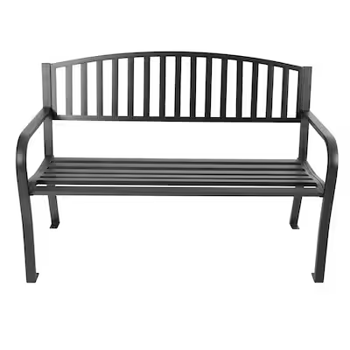
It is their desire to donate furniture for the “front porch” of the Papa Morris building to aide in an cozy outdoor space our seniors can enjoy cards, book club discussions, or just outdoor relaxation as a community.
Please see the photos below of the proposed purchases:
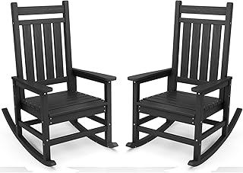

Please advise if I can accept this donation from Woodmen Life. They would like to deliver this in June.

Vangie Rodenbeck
May 19, 2026

