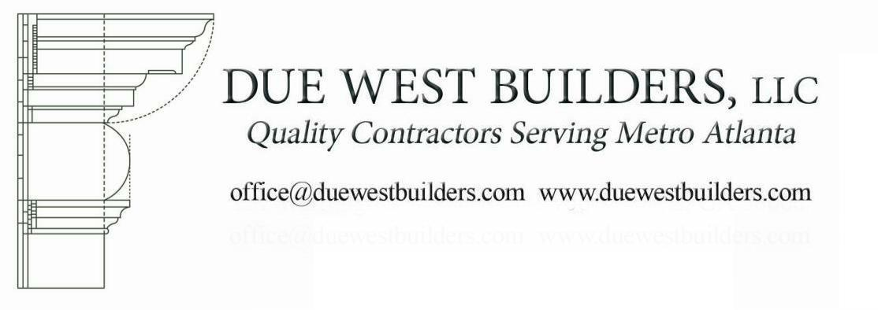
Due West Builders, LLC
P.O. Box 5209
Marietta, GA 30061-5209

November 5, 2021
To: Mr Chad Kastner, Croy Engineering
200 Cobb Parkway N # 413
Marietta, GA 30062

RE: Bid for City of Powder Springs Cultural Arts Center Remodel per plans by CSC Design Inc dated 10-22-21.
Due West Builders, LLC bids:
$43,600
The work to include the following:
- Provide desks with acrylic sheets per drawings;
- Provide Electrical per drawings;
- Provide Transaction Window 1 and 2 per drawings;
- Provide sheetrock per drawings;
- Provide painting per drawings;
- Final clean up and trash removal.

Exclusions / Extras
1). Any additional work not described above.

The above work should be completed in approximately 8 weeks after the work is awarded. Payments for work completed to be made within 15 days of submittal of invoices from Due West Builders, LLC.
Thank you for the opportunity to prepare this bid for you. We look forward to working with you on this project. If you have any questions, please feel free to call me at 770.231.6495.

Acceptance of Bid by the City of Powder Springs and by Due West Builders, LLC below shall constitute a Contract to complete the described work.

Sincerely,
Steve Smith, Manager
Due West Builders, LLC

Acceptance of Bid in the Amount of $____________

By City of Powder Springs

Acceptance of Bid in the amount of $_____________

By Due West Builders, LLC

