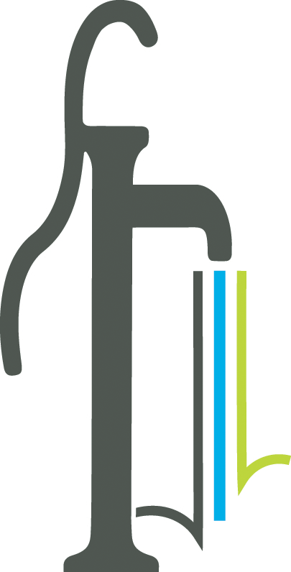 Proclamation
Parks & Recreation Month 2024

WHEREAS parks and recreation are an integral part of communities throughout this country, including the City of Powder Springs; and

WHEREAS parks and recreation promote health and wellness, improving the physical and mental health of people who live near parks; and

WHEREAS parks and recreation increase a community’s economic prosperity through increased property values, expansion of the local tax base, increased tourism, the attraction and retention of businesses, and crime reduction; and

WHEREAS our parks and natural recreation areas, including Powder Springs Park, Thurman Springs Park, Silver Comet Trail Linear Park, Wildhorse Creek Park, Seven Springs Water Park and the neighborhood parks and trail systems, ensure the ecological beauty of our community and provide a place for all to connect with nature and each other and recreate outdoors; and

WHEREAS the U.S. House of Representatives has designated July as Parks and Recreation Month, and the City of Powder Springs recognizes the many benefits derived from parks and recreation as well as the efforts and talents of its parks and recreation staff Travis Landrum, Michele Coursey, Lindsey Landers, Dee Chappell, Julia Kilgore and Vangie Rodenbeck; and

NOW THEREFORE, BE IT PROCLAIMED BY the Mayor and Council for the City of Powder Springs that July is recognized as Park and Recreation Month in the City of Powder Springs.

IN WITNESS WHEREOF, we have set our hand and caused the seal of the City of Powder Springs to be affixed this 15th day of July 2024.

