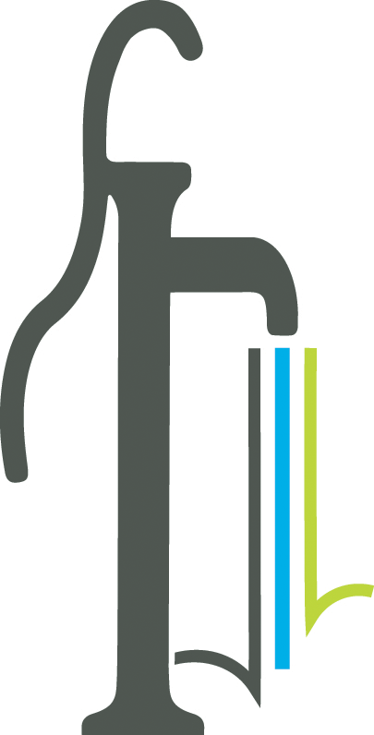 Proclamation
National Safety Month
June 2024

WHEREAS National Safety Month is celebrated in June each year to focus on how we can keep our environments safe and free from danger; and

WHEREAS By learning about safety measures, we can make a difference in our community, at home and at work, whether learning CPR, using an AED, wearing sunscreen, staying hydrated, being aware of extreme heat alerts and seeking places with air conditioning to keep cool, cleaning up spills, keeping floors clean and clear of clutter, wearing proper shoes and clothing or other protective equipment, using a seatbelt, maintaining our vehicles, driving without distraction of our cellphones, or learning to identify and avoid hazardous conditions; and

WHEREAS Established in 1996, National Safety Month is intended to raise awareness of leading causes of preventable injuries and health risks and to decrease the numbers of injuries and deaths at work, on the road and at home.

THEREFORE, BE IT PROCLAIMED by the Mayor and Council for the City of Powder Springs that National Safey Month in June is an important reminder that we should all be aware of our surroundings and potential risks to avoid accidents and injuries and work together to create a safer environment for ourselves and our community.

IN WITNESS WHEREOF, we have set our hand and caused the seal of the City of Powder Springs to be affixed this 3rd day of June 2024.

_____________________________

_____________________________

_____________________________

_____________________________

_____________________________

_____________________________

