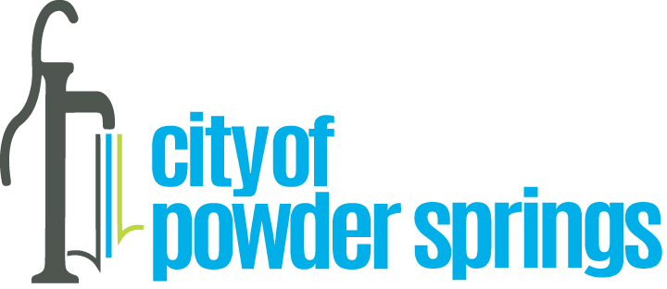

Proclamation
Public Works Appreciation Week

WHEREAS, public works professionals focus on infrastructure, facilities and services that are vital to sustainable and resilient communities and to the public health, quality of life and well-being of our community; and
WHEREAS, these infrastructure, facilities and services could not be provided without the dedicated efforts of public works employees;
WHEREAS, it is in the public interest for citizens and civic leaders to gain knowledge of and maintain a progressive interest and understanding of the importance of public works and public works programs;
NOW THEREFORE, BE IT RESOLVED, that the Mayor and Council for the City of Powder Springs proclaims as Public Works Appreciation Week, May 15 to May 22, 2022 and urges all citizens to join them in recognizing and paying tribute to our public works employees and to recognize the substantial contributions they make in protecting our health, safety and quality of life.

IN WITNESS WHEREOF, we have hereunto set our hand and caused the seal of the City of Powder Springs to be affixed this 16th day of May 2022.

_____________________________ _______________________________
Albert Thurman, Mayor Henry Lust, Mayor Pro Tem, Ward 1

_____________________________ _______________________________
Doris Dawkins, Ward 2 Dwayne Green, Ward 3

_____________________________ _______________________________
Patrick Bordelon, At Large Post 1 Patricia Wisdom, At Large Post 2

