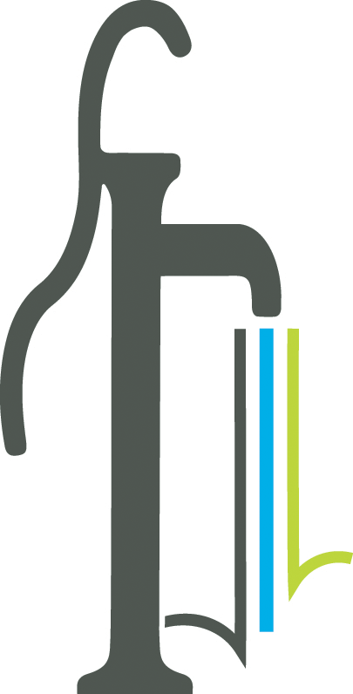 Proclamation
Economic Development Week
May 12 – 16, 2025

WHEREAS the International Economic Development Council is the largest professional economic development organization dedicated to serving economic developers, providing leadership and excellent in economic development for its members, and

WHEREAS economic developers promote economic well-being and quality of life for their communities by creating, retaining, and expanding jobs that facilitate growth, enhance wealth, and provide a stable tax base, and

WHEREAS economic developers stimulate and incubate entrepreneurism to help establish the next generation of new businesses, the hallmark of the American economy, and

WHEREAS economic developers are engaged in a wide variety of settings and attract and retain high-quality jobs, develop vibrant communities, and improve the quality of life in their regions, and

WHEREAS Since 2016, Economic Development Week has been a time to celebrate the incredible impact that economic development organizations and professionals have in their communities, and this year, the focus is on the Power of Partnerships to celebrate the collaborations that drive innovation, growth, and lasting change in local economies.

NOW THEREFORE We, the Mayor and Council for the City of Powder Springs, do hereby proclaim the week of May 12 - May 16, 2025 as Economic Development Week, and celebrate those individuals who positively impact life in our community. IN WITNESS WHEREOF, we have hereunto set our hand and caused the seal of the City of Powder Springs to be affixed this 5th day of May 2025.

_____________________________

_____________________________

_____________________________

_____________________________

_____________________________

_____________________________

