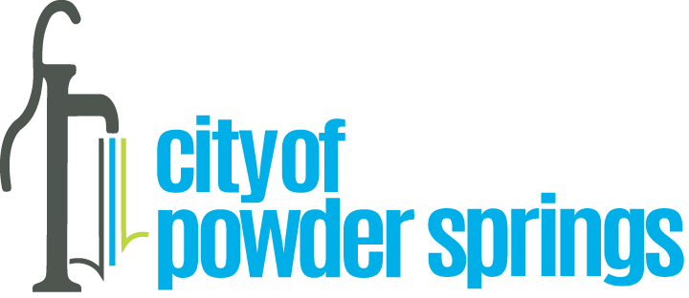

Diversity, Equity & Inclusion Program Proclamation
WHEREAS the strength of the City of Powder Springs is composed a diverse community of citizens, businesses and employees; and
WHEREAS the City recognizes that fostering an environment of diversity equity and inclusion is essential for the success and well-being of our city; and
WHEREAS the pursuit of justice, equity, and inclusion is a fundamental principle that binds the Powder Springs community together; and

WHEREAS the City acknowledges that systemic barriers which create barriers to equal opportunity for marginalized sectors of our country must be confronted and addressed to ensure fairness and equal access for all; and

WHEREAS the contributions of each individual, regardless of race, ethnicity, gender, religion, sexual orientation, disability, or socio-economic status, will enrich the City’s collective experience; and

WHEREAS the City affirms that promoting diversity, equity, and inclusion is not only a moral imperative but also a strategic advantage for a sustainable community and economy.

NOW, THEREFORE, The Mayor and Council of the City of Powder Springs, do hereby proclaim the following:

- Diversity: We celebrate the mosaic of backgrounds, cultures, and identities that make up our city. We commit to actively seeking out and embracing diverse perspectives in all aspects of our governance of the city.
- Equity: We commit to addressing historical and systemic inequities by ensuring fair treatment, access, and opportunities for every citizen, business, council member, and employee. We recognize that equity requires specific actions to fulfill this commitment.
- Inclusion: We create an environment where everyone feels valued, respected, and heard. We reject discrimination and bias, fostering a sense of belonging for all.
- Education and Awareness: We will educate ourselves and our communities about the importance of DEI. We will engage in open dialogue, learn from one another, and challenge our assumptions.
- Accountability: We hold ourselves accountable for progress. We will measure our efforts, adjust our strategies, and transparently report on our achievements.
IN WITNESS WHEREOF, the Mayor and Council have caused the seal of the City of Powder Springs to be affixed this 1st day of April 2024.

