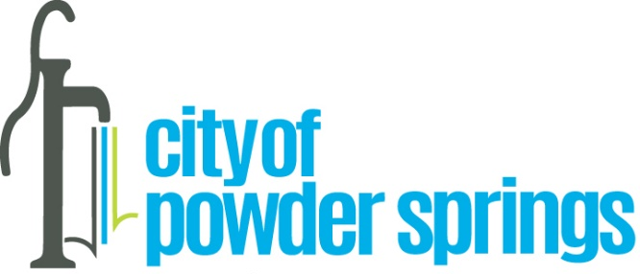

In recognition of Red Ribbon Week

WHEREAS Annually Red Ribbon Week is celebrated October 23 through October 31 to highlight the importance of living a drug free life; and

WHEREAS during this annual observance, youth, and adults pledge to increase their knowledge about the destructive effects of drug abuse, including prescription drug misuse; and

WHEREAS Reb Ribbon Week Is the nation’s oldest and largest drug prevention awareness program, and

WHEREAS Red Ribbon Week started after the death of a Drug Enforcement Administration special agent, Enrique Kiki Camarena who in 1985 was murdered by drug traffickers he was investigating, and after his death, people wanted to honor his sacrifice; and

WHEREAS wearing red ribbons demonstrates honor to the sacrifices made by Camerana and others who have lost their lives in the fight against drugs and to show intolerance for drugs at school, in the workplace and in communities; and
WHEREAS the hard work and determination of the Young Marines of the Marine Corp League to foster a healthy, drug-free lifestyle help advance the mission of Red Ribbon Week; and
WHEREAS the theme of Red Ribbon Week in 2023 is “Be kind to your mind; live drug free” to emphasize the importance of mental well-being and drug prevention for our youth.
NOW THEREFORE, the Mayor and Council hereby recognize Red Ribbon Week and encourage all citizens to support Red Ribbon Week by wearing red ribbons, by talking to each other about healthy choices, especially our youth, and to join Young Marine Lance Corporal William Hughes and other Young Marines of Georgia in promoting drug-free lifestyles.

IN WITNESS WHEREOF, we, the Mayor and Council for the City of Powder Springs have caused the seal of the City to be affixed this 16th day of October 2023.

