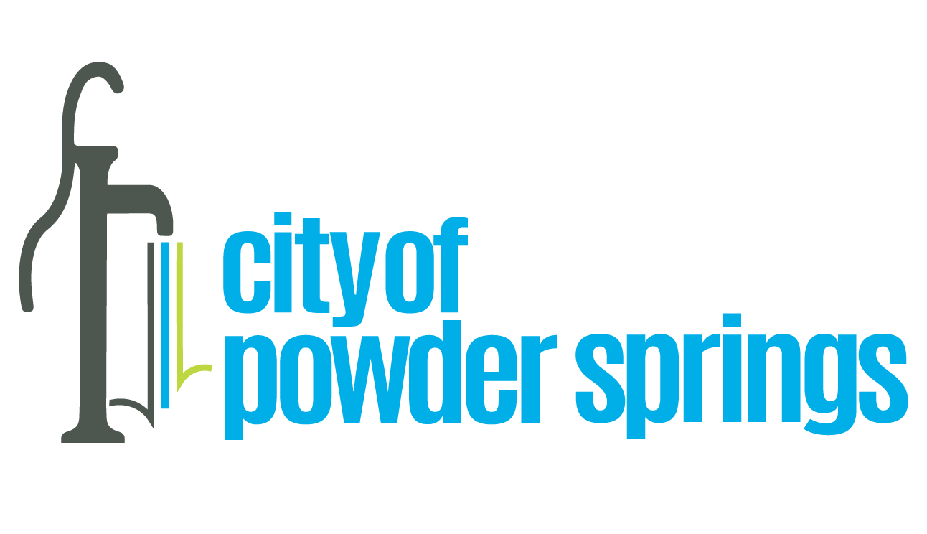

Date: July 28, 2023

Project: Police Mental Health Co-response

Recommendation: Staff recommends approval of the attached Memorandum of Understanding (MOU) with Cobb County and the Cobb County Community Services Board to enable cooperation in responding to non-emergency behavioral health situations that may occur in the Powder Springs area.

Background: The Mayor and Council chose to direct a portion of the funds from the City’s ARPA grant to support the addition of a mental health component to responses by local police to calls involving potential behavioral health needs. Several metro police agencies, including Cobb County, have also invested funds to form special units to respond to these types of calls. The units include a specially-trained police officer and a trained mental health clinician, who together respond to police calls involving behavioral health situations.

If the MOU is approved, it is the staff’s intent to partner with the Cobb County Police Department to support its behavior health response units, called PATH units. Cobb County has teamed with Highland Rivers Behavioral Health to create two of these PATH units but has not been able to fully staff the second unit. Our intent is to provide an appropriately trained police officer one day per week, funded by the City’s ARPA grant, to fully staff the second of the County’s PATH units. The unit will be available to respond to calls in the Powder Springs area and will be in operation weekdays, typically 9 AM to 4 PM.

Staff anticipates that funding overtime for an officer to support the area PATH unit for one shift per week will cost less than $2,000 each month including fringe benefits. Cobb County will provide the police vehicle, so we do not anticipate any significant costs to participate other than the cost of the officer.

Staff recommends approval of the MOU with Cobb County to enable the City of Powder Springs’ Police Department to support the area PATH unit serving Powder Springs.

Prepared by: Wayne P. Wright, ARPA Program Manager

