Proposed Text Amendment:

Table 2-3
Permitted and Special Uses in
Mixed-Use and Non-residential Zoning Districts
Use | See also | MXU | O-I | NRC | CRC | CBD | BP | LI | HI
Funeral home, mortuary, or mausoleum | Section 4-151 | X | X | X | S | X | S | P | P

ARTICLE 3
USE DEFINITIONS
Funeral home: A building used for human funeral services. Such building contains a chapel and may include space and facilities for embalming and the performance of other services used in the preparation of the dead for burial or cremation, the performance of autopsies and other surgical procedures, the indoor storage of caskets, funeral urns, and other related funeral supplies, and/or the indoor storage of funeral vehicles means a building or facility utilized for preparations and ceremonies for deceased persons prior to burial or cremation. All funeral homes must comply with state regulations as well as the rules promulgated by the Georgia State Board of Funeral Service, as may be amended from time to time. A funeral home may have an accessory crematory within the main building in compliance with manufacturer's instructions and any state or federal laws.

ARTICLE 4
SPECIFIC USE PROVISIONS

Sec. 4-151. Funeral Homes, mortuary, or mausoleum

- Funeral Homes that are legally non-conforming that requires to add accessory uses to existing floor space without any building expansion will require a Special Use approval.

City of Powder Springs Definition
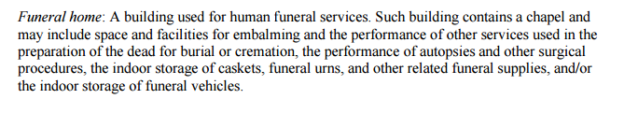

Table 2-3 Permitted and Special Uses in Mixed-Use and Non-residential Zoning Districts
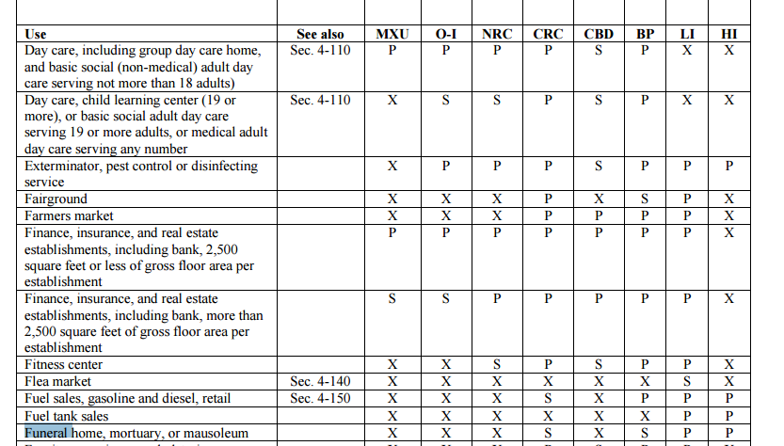

Acworth Definition
Permitted:
Permitted in C-2, Community retail commercial
Permitted in OP, Office professional
Permitted in LI, Light industrial
Permitted in HI, Heavy industrial

Not Permitted
Not permitted in C-1, Neighborhood retail commercial
Not permitted in OIT, Office institutional transitional
Not permitted in LRO, Low-rise office

Conditions: Funeral homes. All structures shall be located and activities conducted at least 100 feet from any property zoned for residential purposes.

Nonconforming Use – May not be expanded in intensity

City of Marietta
Definition
Permitted:
Permitted in the CBD, Central Business District
Permitted in HI, Heavy Industrial
Permitted in LI, Light Industrial
Permitted in CRC

Not Permitted
Not permitted in OS, Office Services
Not permitted in OIT, Office Institutional
Not permitted in NRC, Neighborhood retail commercial

Conditions:
All structures shall be located and activities conducted at least 100 feet from any property zoned for residential purposes.

Nonconforming Use – May not be expanded in intensity

Cobb County

Definition
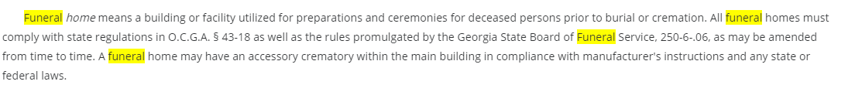
Permitted:
4 – NRC, neighborhood retail commercial
5 – OI, Office and Institutional
8 – CRC, Community Retail Commercial
9 – RMR, Residential Mid-Rise
10 – OMR, Office Mid-Rise

3 – NS, Neighborhood Shopping
4 – PSC, Planned Shopping Center
6 – GC, General Commercial
7 – RRC, Regional Retail Commercial
9 – LI, light industrial

Not permitted:
LRO, Low-Rise Office
LRC, Limited Retail Commercial
UVC – Urban Village Commercial
PVC – Planned Village Commercial

Conditions: (with a maximum height of two stories and a 25-foot buffer adjacent to all residentially zoned properties).
Nonconforming Use – May not be expanded in intensity

City of Smyrna
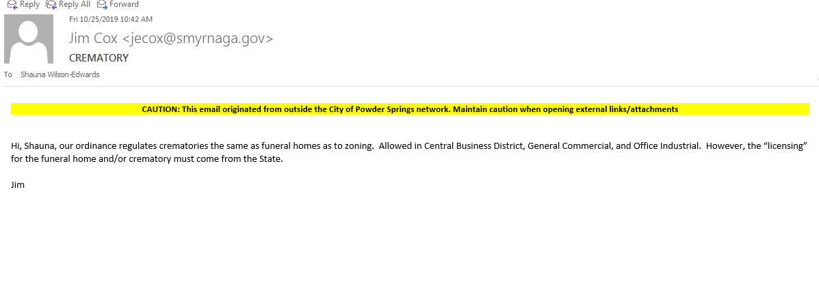

City of Austell
Allows Funeral Homes and Crematory in the HI and LI district.

