Memorandum to: Planning & Zoning Commission
From: City Planning Staff
Copy: Applicant
Applicant: Infinite 1 Holdings, LLC
Application: Rezoning a 1.27 acre tract from R15 to CRC for administrative offices and a training facility for disabled adults, greater than 19 in number.
Location: 4144 Old Austell Rd, within land lot 946, 19th District, 2nd Section, Cobb County, Georgia. PIN: 19094600330.

Property Location and Survey:
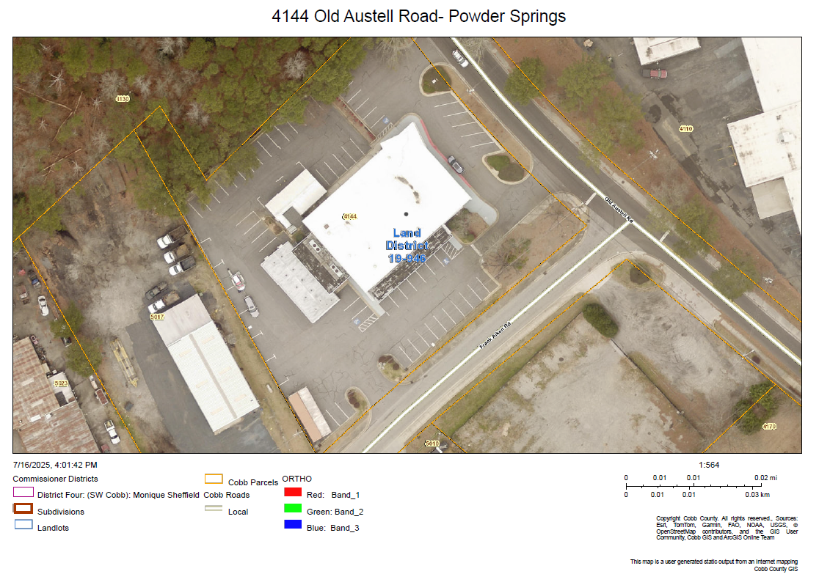

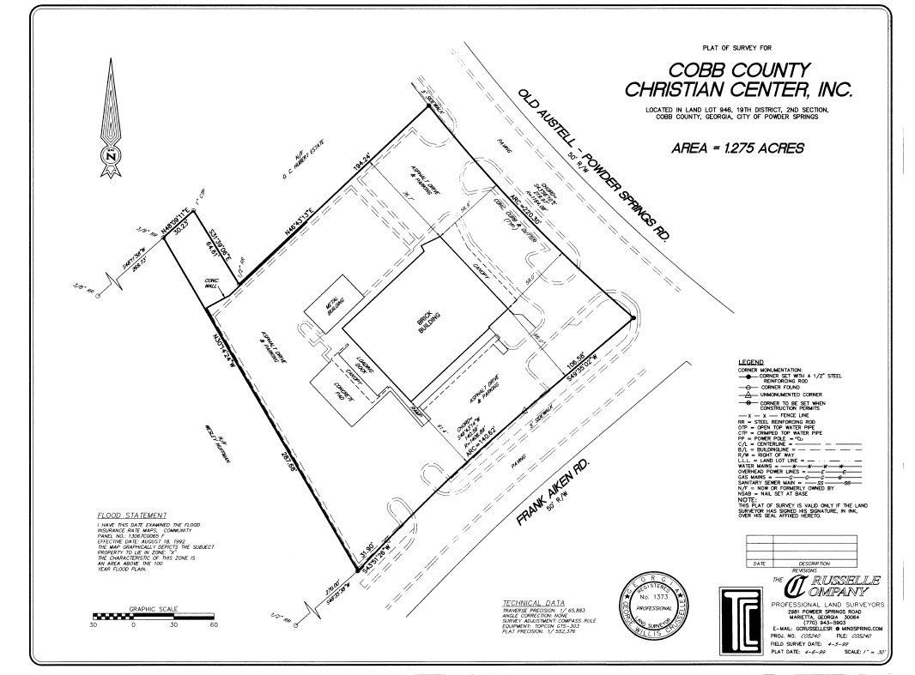

Criteria for rezoning decisions.
- Whether the proposed zoning district and uses within that district are compatible with the purpose and intent of the comprehensive plan. The future development map and the future land use plan map of the city's comprehensive plan shall be used in decision-making relative to amendments to the official zoning map, in accordance with Table 13-1 of the UDC.
The Future Development Map represents a general concept of future land use patterns and prescribes future land uses and appropriate zoning districts in the event a rezoning of property occurs. The property, 4144 Old Austell Road, is designated as on the Future Development Map as Professional Employment Center and the Future Land Use Map. One consistent zoning district in these categories is CRC. The following is from the City’s Comprehensive Plan regarding Professional Employment Centers.
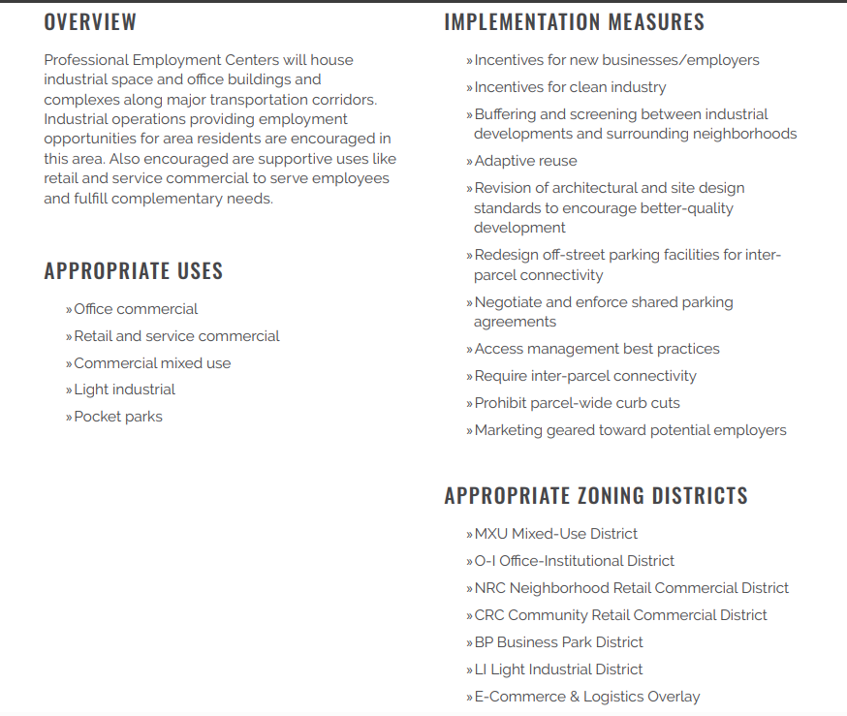

- Whether the proposed zoning district and uses permitted within that district are suitable in view of zoning and development of adjacent and nearby property.

The zoning and development of properties near or adjacent to the subject property are commercial and light industrial and used for commercial and industrial purposes. The industrial uses do not involve heavy operations, with most consisting of automotive repair facilities.

The property immediately north of the subject property is zoned and used commercially. Properties located northwest are zoned commercial but are currently used residentially. The property immediately west of the property is vacant and fronts Grady Grier Drive, which is a residential road in an established residential area.
The proposed use would take place in an existing facility, originally constructed and used as an institutional post office and thereafter as a church. The structure has been vacant for at least a year. No new construction is planned.

Using the property as an office and adult day care and training facility may be considered suitable in view of the zoning and uses of the nearby properties.

- Whether the existing use or usability of adjacent or nearby property will be adversely affected by one or more uses permitted in the requested zoning district.

Adult day care and training centers may bring caregivers, family members and service providers to the area, which can increase visits to nearby retail or commercial establishments and would thus have a positive impact. Day care and training tend to be long-term with consistent operations, which can contribute to land use stability. Also, adult day care may be viewed as socially beneficial, which can enhance the public perception of a commercial area, especially if the facility is well-maintained and professionally operated.

There may be increased demand for parking or drop-off zones. This can be mitigated through site design and traffic management plans. Outdoor activities by the day care are not anticipated but if conducted it can be managed to mitigate impacts to surrounding properties from activity noise. Hours of operation can mitigate needed transportation services.

The proposed use may be considered generally compatible with commercial zones and would not be expected to negatively impact property values or business operations when properly managed.

However, if the number of clients served generates frequent drop-offs and pick-ups, which can increase traffic, a parking and operations plan can mitigate the increased traffic. Additionally, adequate parking and access exist that would mitigate the increased traffic.

- Whether there are substantial reasons why the property cannot or should not be used as currently zoned.

The property is zoned R15 and is improved with an institutional structure- a former post office and church. Both uses are permitted within a residential district but said uses are unlikely to resume operations. The former post office relocated to a larger property that accommodated its expanded operational needs, and the structure has remained vacant since the more recent church operations ceased. Use of the property as zoned, residential, may be considered incompatible with the surrounding uses.

Existing Structure
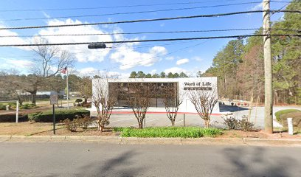

- Whether public facilities such as roads, schools, water and sewer utilities, and police and fire protection will be adequate to serve the proposed zoning district and uses permitted.

The property is currently improved with an existing structure and served by needed utilities. It is easily accessible, and police and fire protection are adequate to serve the proposed use.

- Whether the proposed zoning district and uses permitted within that zoning district are supported by new or changing conditions not anticipated by the comprehensive plan or reflected in the existing zoning on the property or surrounding properties.
The proposed office and adult day care and training facility may reflect a response to evolving demographic and community needs that were not fully anticipated when the existing residential zoning district of the property itself and nearby residential uses were originally established. The aging population in Georgia and across the nation has grown significantly, increasing demand for non-institutional care options such as adult day services. These facilities provide essential support for older adults and individuals with disabilities, enabling them to remain in their communities while receiving supervised care, health services, and social engagement. This demographic trend represents a shift in community needs.
Adult day care centers contribute to this vision by offering services that benefit not only participants but also caregivers and families. Their presence aligns with contemporary expectations for neighborhood amenities that support health and wellness. The facilities typically operate during daytime hours, generate limited traffic if hours and size are limited and/or managed, and maintain quiet, supervised environments. These characteristics may aid in making them compatible with the varying surroundings, especially when managed and supervised properly and buffered appropriately.
The facility may be regarded as promoting public health and welfare by addressing unmet needs for daytime supervision, medical oversight, and social interaction among vulnerable populations. It also supports workforce participation by enabling caregivers to maintain employment while their loved ones receive care. The proposed adult day care and training facility may represent a reasonable and forward-looking adaptive re-use of an existing facility near the edge of commercially zoned and used and residentially used area near by the boundary of the proposed site.

- Whether the proposed zoning district and uses permitted within that zoning district reflect a reasonable balance between the promotion of the public health, safety, morality or general welfare and the right to unrestricted use of property.

The establishment of adult day care and training facilities within commercial and industrial zoning districts represents a reasonable balance between the promotion of public health, safety, morality, and general welfare, and the preservation of private property rights.
Adult day care centers serve as a vital function by providing supervised care, medical oversight, and social engagement for older adults and individuals with disabilities. These services directly support public health objectives, reduce caregiver burden, and promote community well-being. Training components further enhance the public good by equipping individuals with skills for employment and independence, thereby contributing to economic development and social mobility.
From a safety and moral standpoint, these facilities offer structured environments that protect vulnerable populations from neglect, isolation, and exploitation. Their presence affirms the community’s commitment to dignity, inclusion, and compassionate care.
At the same time, adult day care and training facilities are generally low-impact uses that respect the rights of property owners. They operate during standard business hours, generate moderate traffic, and do not produce noise, pollution, or hazardous conditions. When located in commercial or light industrial zones, they are compatible with surrounding uses and often contribute positively to the area by increasing foot traffic and supporting nearby businesses.

Staff recommends approval of the application subject to the following conditions:

1. Licensing and Compliance
- The facility shall maintain all required state and local licenses and certifications for adult day care and training operations.
- The operator shall comply with all applicable provisions of the Georgia Department of Community Health and any other relevant regulatory agencies.

2. Hours of Operation
- The facility shall operate only between the hours of 7:00 a.m. and 6:00 p.m., Monday through Friday.
- No overnight stays or weekend operations shall be permitted without prior approval.

3. Capacity and Staffing
- The maximum number of participants shall not exceed 25 at any one time.
- The facility shall maintain a minimum staff-to-participant ratio in accordance with state regulations, with at least one staff member trained in CPR and first aid on-site at all times.
4. Parking and Traffic Management
- Adequate on-site parking shall be provided for staff, visitors, and transportation vehicles, in accordance with the city’s zoning code.
- A designated drop-off and pick-up area shall be provided to minimize traffic congestion and ensure safe access.
- A traffic management plan may be required if the facility serves more than 25 participants.
5. Noise and Activity Control
- All activities shall be conducted indoors unless otherwise approved. Any outdoor activities must be supervised and limited to designated hours.
- Noise levels shall comply with the city’s noise ordinance and shall not disrupt adjacent residential or commercial uses.
6. Site Design and Landscaping
- The facility shall provide appropriate landscaping buffers and screening between the facility and adjacent residential properties.
- Signage shall be limited to one monument or wall sign, and shall be non-illuminated or externally lit only.

7. Accessibility and Safety
- The facility shall comply with the Americans with Disabilities Act (ADA), including accessible entrances, restrooms, and pathways.
- Emergency exits, fire suppression systems, and evacuation plans shall be reviewed and approved by the local fire marshal.
8. Community Engagement
- The operator shall provide a community liaison contact and respond to neighborhood concerns in a timely manner.
- An annual report summarizing operations, community feedback, and any incidents shall be submitted to the city’s planning department.
9. Applicant and Approval Specific
- Any expansion of services, hours, or capacity or a change in owner or operator shall require an amendment to this approval.

