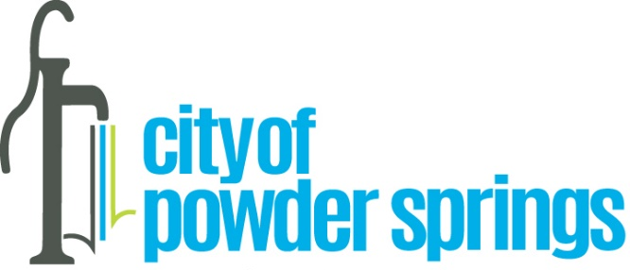
Lester Hicks – Earth Day Steward for Pick It Up Powder Springs
WHEREAS April is recognized as National Earth Month to raise awareness about the vulnerability of our planet and the need to take steps to protect our natural resources; and
WHEREAS a resident of the Powder Springs Community, Mr. Lester Hicks has helped lead efforts with award winning programs to change behaviors in ways to protect and preserve our environment, including 21 awards from the State of Georgia for his pollution prevention and community service efforts; and

WHEREAS Lester Hicks is also an author, penning Against All Odds; 4th Down and Forever, which was inspired by the air tragedy that took the lives of 75 people in the Marshall football program, after which he joined surviving players to help rebuild the football program and was later honored by Marshall with the Distinguished Alumnus award; and

WHEREAS Lester Hicks has also spent his life volunteering for numerous community organizations such as WellStar Hospice Home Care, Cobb Literary Council and school mentoring and was recognized by his employer for changing the safety culture of the company; and

WHEREAS it is fitting to recognize during Earth Month the contributions by Lester Hicks in protecting our environment and natural resources;

NOW, THEREFORE, BE IT PROCLAIMED by Mayor Al Thurman and members of the City Council that Lester Hicks is congratulated and honored for his invaluable contributions to community and to protecting our environment and natural resources and is named Earth Day Steward for 2023 on Pick It Up Powder Springs during Georgia Cities Week.

IN WITNESS WHEREOF, we, the Mayor and Council for the City of Powder Springs have hereunto caused the seal of the City to be affixed this 17th day of April, 2023.
_____________________________
_____________________________
_____________________________
_____________________________
_____________________________
_____________________________

