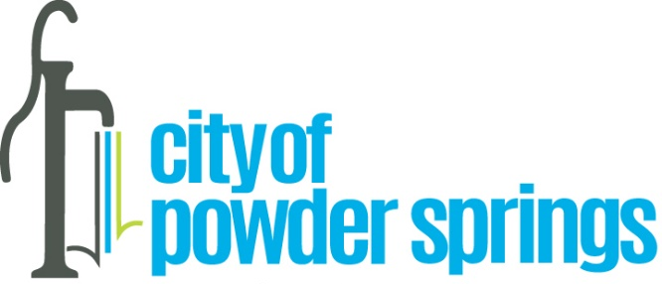

National Preparedness 2022

WHEREAS National Preparedness Month is an observance each September to raise awareness about the importance of preparing for disasters and emergencies that could happen at any time and to encourage all Americans to improve emergency preparedness in their communities by doing four key things: stay informed about different emergencies that could occur and the appropriate response; make a family emergency plan; make an emergency supply kit; and get involved in the community by staying prepared for emergencies; and
WHEREAS this year’s National Preparedness theme is “A lasting legacy: Prepare for disasters to create a lasting legacy for you and your family;” and
WHEREAS residents are encouraged to develop and practice emergency plans that include a communications strategy, emergency meeting locations, a preparedness kit for home, work and travel, taking into consideration the needs of the members of their household, including their pets; and
NOW, THEREFORE, we, the Mayor and Council for the City of Powder Springs hereby call upon residents to help the City of Powder Springs become safer and more resilient and help first responders by training how to respond during an emergency, planning what to do when disaster strikes, developing individualized plans, assembling emergency supply kits, learning lifesaving skills such as CPR and first aid, reviewing insurance policies and coverage for hazards, storing and protecting critical documents, and reviewing the resources available at www.ready.gov help ensure a resilient and prepared City.
Dated this 3rd day of October 2022.

