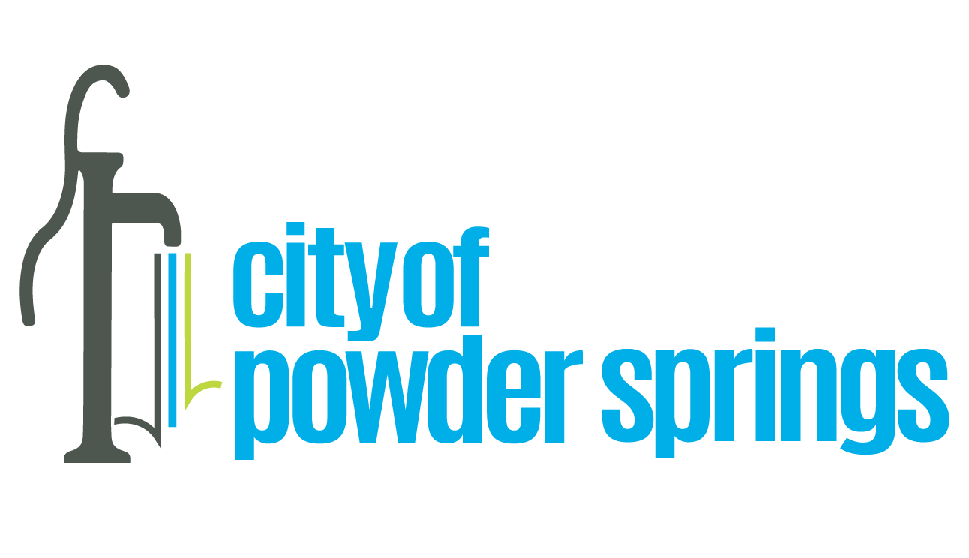

Date: July 28, 2023

Project: Stormwater Structure Cleanout on Sailors Parkway

Recommendation: Staff recommends awarding contract for cleaning stormwater structures on Richard D. Sailors Parkway to Golden Rule Plumbing, Inc. in the amount of $17,600.00 using American Rescue Plan Act grant funds.

Background: The Mayor and Council chose to direct a portion of the funds from the City’s ARPA grant to address stormwater infrastructure needs throughout the City. Staff identified this small project as a significant issue contributing to hazardous conditions on Sailors Parkway during rain storms. Ten stormwater inlets have become severely clogged with silt and debris, some as deep as two feet. In April this year the Mayor and Council awarded the contract to
HydroExcavators, LLC to perform this maintenance work.

Unfortunately, HydroExcavators was ultimately unable to complete the contracting process in order to begin the work. Because the maintenance work on Sailors Parkway still needs to be done, staff recommends awarding the contract to Golden Rule Plumbing, Inc., which provided a quote slightly higher than that of HydroExcavators. Golden Rule is an experienced and reputable contractor known to City staff.

Staff recommends awarding the contract for stormwater structure cleaning on Sailors Parkway to Golden Rule Plumbing, Inc. for a total of $17,600.00, which includes the base price of $16,000.00 and a ten-percent contingency ($1,600.00) to be used only with prior approval of the City.

Prepared by: Wayne P. Wright, ARPA Program Manager

