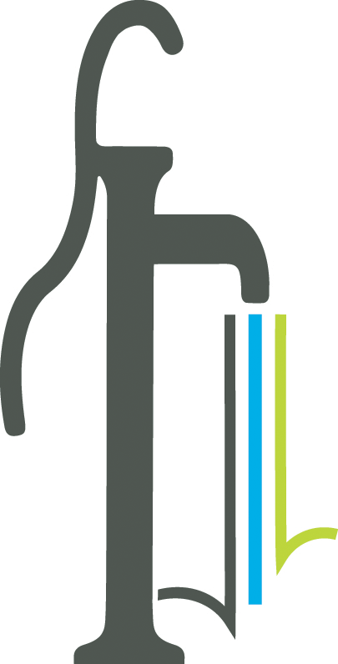 Proclamation
National Public Works Week
May 21-27, 2023

WHEREAS following the Great Depression, President Roosevelt established services and programs that changed public works in our nation, and in 1937, the American Public Works Association was formed and later formally recognized in 1960 by the United States Senate when the first public works week was organized;

WHEREAS Public works professionals focus on infrastructure, facilities and services, such as designing, planning, operating and improving the City’s roads, bridges, trails and sidewalks; graffiti removal; solid waste management, storm drain repair; pavement materials assessments and traffic control devices that are vital to sustainable and resilient communities and to the public health, quality of life and well-being of our community; and

WHEREAS these infrastructure, facilities and services could not be provided without the dedicated efforts of public works employees; and

WHEREAS it is in the public interest for citizens and civic leaders to gain knowledge and understanding of the importance of public works and public works programs, and the theme for 2023 is Connecting the World through Public Works; and

NOW THEREFORE, BE IT RESOLVED, that the Mayor and Council for the City of Powder Springs proclaims as Public Works Appreciation Week, May 21-27, 2023 and urges all citizens to join them in recognizing and paying tribute to our public works employees and recognize the substantial contributions they make in protecting our health, safety and quality of life.

IN WITNESS WHEREOF, we have hereunto set our hand and caused the seal of the City of Powder Springs to be affixed this 15th day of May 2023.

_____________________________

_____________________________

_____________________________

_____________________________

_____________________________

_____________________________

