In Appreciation to the 2018
Summer Youth Camp Sponsors

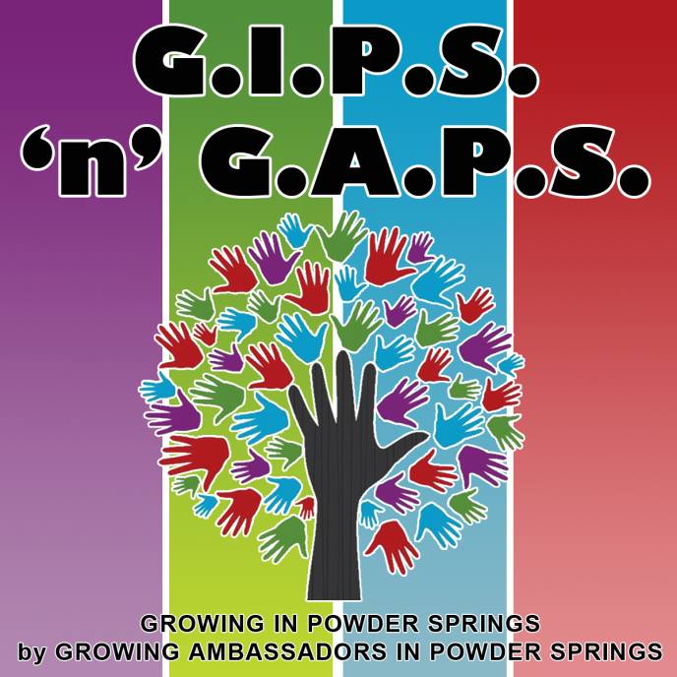

Gold
Croy Engineering | Macland Presbyterian | Powder Springs Task Force | Tapp Middle School
City of Powder Springs | Powder Springs First United Methodist Church

Silver
Signature Sign Service | Animal Care Clinic | Gregory, Doyle, Calhoun & Rogers | The Trophy case
Bronze
Rid Property Services | American Legion | Dillon Insurance Agency | Greener Pastures

