August 30, 2022.

Adam Baker
SA Land Group
475 East Main Street, Suite 132,
Cartersvile, GA 301271.

RE: Rezoning. Change in Zoning Conditions. The property is located at 31493189, 3215, and New Macland Road, within land lots 725 and 682 of the 19th District, 2nd Section, and Cobb County, Georgia. PINs: 19072500020, 19072500090, 19068200030.

Dear Neighbors:

We are hereby providing you notice of a request to change zoning conditions to remove the requirement to revise the proposed site plan, per the recommendations of a review conducted by the city’s comprehensive plan consultant, TSW. The property is located at 3189, 3215, and 3149 New Macland Road. We propose developing 41 residential units in a townhome development at the site.

Meetings will be held at 4181 Atlanta Street in the Ford Reception Hall – Building 2 (agenda meetings), and Cultural Arts Center – Building 1 (public hearings), and via zoom. Zoom links will be available at www.cityofpowdersprings.org.

The application will be heard before Mayor and City Council on the following dates:

Mayor and City Council: Wednesday, September 14, 2022 (Agenda Meeting) at 5:00 pm.
Visit www.cityofpowdersprings.org for ZOOM link and meeting details.

Mayor and City Council: Monday, September 19, 2022 (Public Hearing) at 7:00 pm.
Visit www.cityofpowdersprings.org for ZOOM link and meeting details.

Please visit our website at www.cityofpowdersprings.org for additional information and instructions. Any changes to our meetings will also be updated on our website.

Should you have any questions please feel free to contact the City of Powder Springs at 770-943-1666 extention 345, or email Shaun Myers smyers@cityofpowdersprings.org, Planning and Zoning Manager at the City of Powder Springs.

Thank you,

___________________
Applicant

Exhibit 1. 3189, 3215, and 3149 New Macland Road.
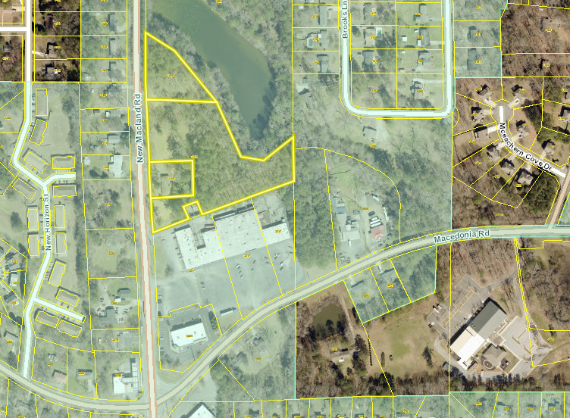

Exhibit 2. Proposed Site Plan.
