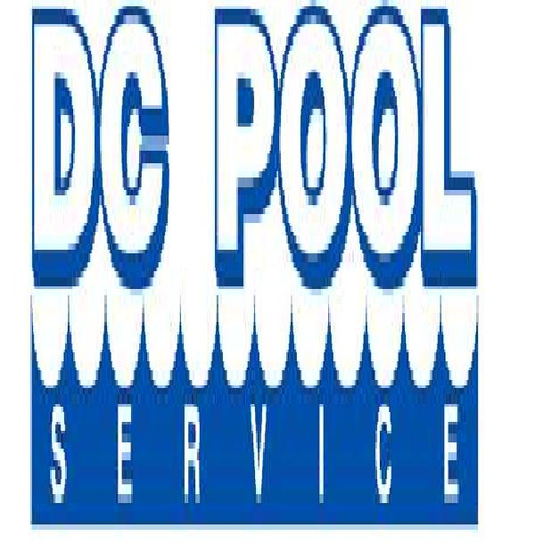
Service Beyond Expectation

1359 Lochstone Drive
Powder Springs, GA 30127
770-262-0092

DC Pool Service proposes to perform the following services at City of Powder Springs Splash Pad for 2023 open season.

Service will begin May 1st, 2023
Service will end October 1st, 2023

Spray Pad Start Up

- De winterize all plumbing, pumps, filters
- Fill surge tank
- Start up pumps, filtration, chemical treatment
- Prepare for county inspection
- Balance chemicals and insure operation of feeders and chemical controller

Spray Pad Maintenance
- Test splash pad water and adjust chemistry when necessary
- Maintain pumps and filtration systems, cleaning hair/lint strainer basket, and backwashing sand filter when necessary
- Maintain chemical feed pump and pulsar feeder
- Calibrate and adjust chemical controller to insure proper operation
- Check operation of automatic water leveler and level of surge tank
- Adjust valves for proper feature height
- Insure system is operating properly and recommend any additional repairs
- Calibrate and adjust UV system as necessary and check for proper operation

Spray Pad Winterizing/Closing
- Drain all pumps, filter, pool plumbing, surge tank
- Disconnect chemical feeders and controller
- Store probes in proper caps

Service and Maintenance Schedule
- Service splash pad once weekly during open season

Total for Splash Pad Services
- $150.00 per visit x 23 visits = $3450.00
- Spray Pad Start up = $500.00
- Spray Pad Winterizing/Closing = $500.00
- Total for all services = $4450.00

Payment Schedule

An invoice will be sent once monthly for any service during the previous month.

To accept terms above , please sign below:

_____________________________ _____________________________
City of Powder Springs Representative DC Pool Representative

