Memorandum
Date: September 28, 2025
To: Planning & Zoning Commission
From: Pam Conner
Subject: Child Caring Institution
PZ: PZ 25 – 016 Special Use - Request to operate a Residential Child-Caring Institution (RCCI) at 5780 Warren Farm Road. PIN: 19073500120

Background:
LaToya Skinner, owner of A Village Called Home, has submitted an application for Special Use Approval to Operate a Residential Child Caring Institution at 5780 Warren Farm Road, concurrently with the proposed amendment to the Unified Development Code permitting said use in all zoning districts subject to various regulatory conditions. Ms. Skinner purchased the property earlier and sought zoning verification that the use was permitted as part of her application to the State for state licensing. At the time the use was not permitted as proposed. When provided a zoning verification letter explaining that the use was allowed for up to 6 children, Ms. Skinner requested council consider a change to its zoning regulations to allow more children.
The council asked staff to prepare an amendment for consideration and asked that the amendment include mitigating conditions to minimize impacts that could result from operation of a larger institutional home. The proposed text amendment is currently before the city, Ordinance 2025-016.

Location:
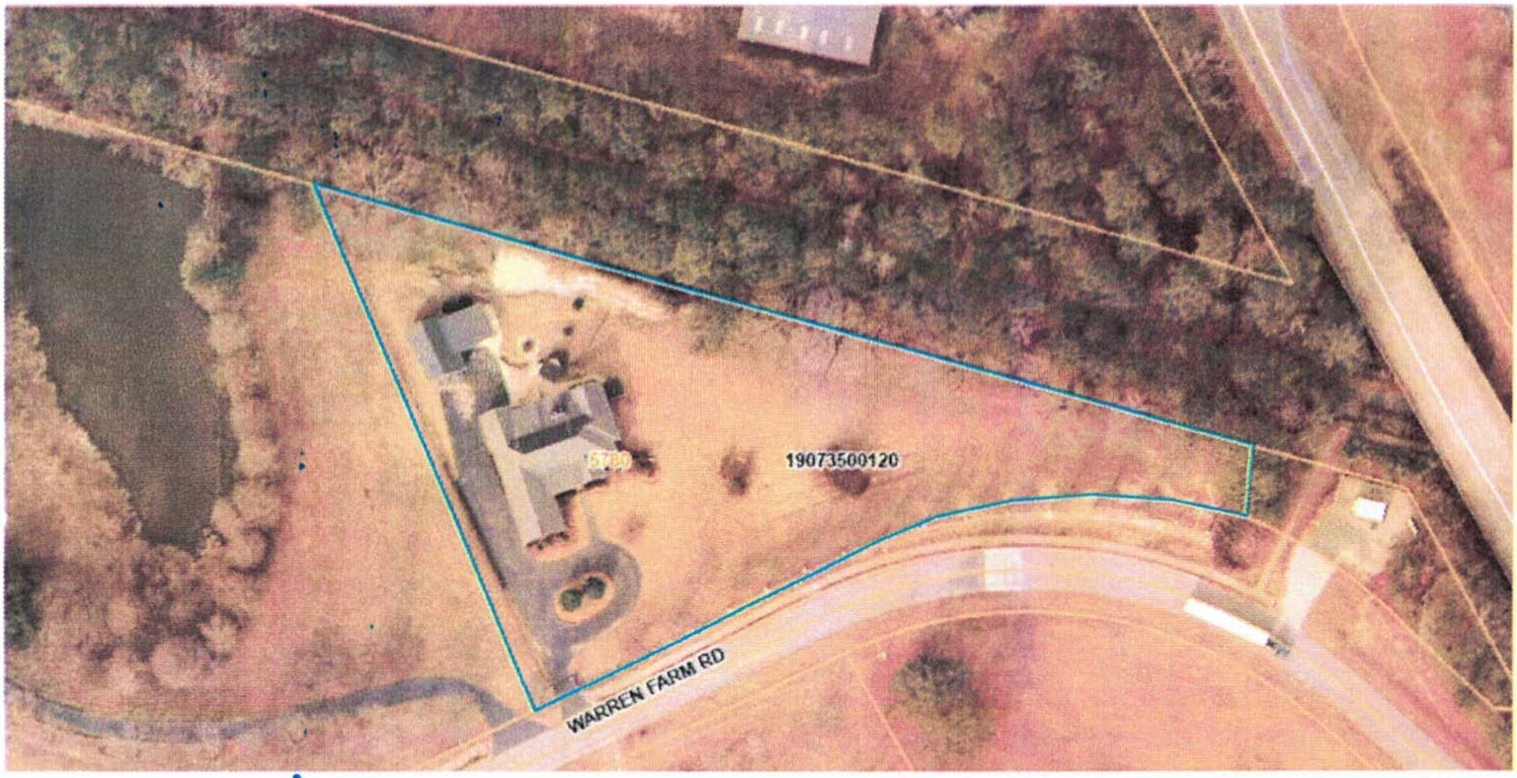

Request:
The proposed facility will provide 24-hour care to children ranging in age from 7 to 18 years. The applicant proposes to serve up to 18 children although the number allowed is dependent upon the available square footage and layout of the home as regulated by the state, which requires 63 square feet of useable floor space per child for sleeping areas.
The applicant also requests variance to modify any requirement that might limit the ability to configure the home layout to comply with state regulations. This will not be considered by the is application and should have its own separate application and hearing.
The applicant states that the subject property is proposed for use as a Residential Child-Caring Institution (RCCI), formerly known as a group home by the state, providing full-time, 24-hour care and supervision for six (6) or more children up to 18 years of age based off the square footage of the residence.
The facility will be licensed through the Georgia Department of Human Services (DHS), Office of Residential Child Care (ORCC) and will meet all state requirements for residential childcare operations, including but not limited to:
  - Providing a structured, safe, and nurturing living environment.
  - Staffing with trained caregivers to provide full-time care and supervision.
  - Offering services that support the emotional, physical, and developmental needs of children in care.
  - Ensuring compliance with physical site requirements, including the provision of a minimum of 63 square feet of usable floor space per licensed bed, as required by Georgia DHS regulations.

The applicant states that all children will be enrolled in school preferably an academy private school to ensure access to quality education and to avoid potential stereotyping. The schools serving the property include: Powder Springs Elementary School, Cooper Middle School and McEachern High School. Private schools include: Praise Academy, Miles Ahead Charter School, Brighton Private School and Hearts Academy of Excellence.
The facility will also offer comprehensive mental health therapy and counseling services aimed at supporting individuals in adapting to life changes, environmental transitions, emotional stressors, or psychological trauma.

In accordance with state rules and regulations governing facility licensure, applicant requests that the square footage per licensed bed meet the minimum of 63 square feet per bed.

Analysis: The UDC provides the following standards for approval. Applicant has offered an analysis of these standards, which staff generally accepts with exceptions noted.
- Whether the proposed special use is consistent with the stated purpose of the zoning district in which it will be located.

The proposed special use as a Residential Child-Caring Institution (RCCI) may be considered consistent with residential zoning districts as such institutions can support stable residential living environments. The applicant notes that the facility will maintain the existing residential character while providing a safe, secure, and supportive setting for children in need of care. While located in a residential area, the home is outside a covenanted community and not subject to any Homeowners Association (HOA). The property is gated, which enhances both safety and privacy. Nonetheless, the use if not properly managed can have a negative impact on the surrounding neighborhood and conditions should be in place requiring proper care and maintenance of the property in addition to the proposed use itself. Accordingly, the lawn and structures should always be maintained per the UDC and International Property Maintenance Requirements. All other codes should be observed as well, including requirements relating to parking, noise, animal control, and outdoor storage.

- Whether the proposed zoning district and use permitted within that district are suitable in view of the zoning and development of adjacent and nearby property.
The surrounding area consists of residential properties. The proposed RCCI will preserve the single-family appearance and character of the home and is intended to operate discreetly within the community so that its different use is not apparent. The gated and secure nature of the residence can serve to lessen impact to surrounding properties and the low-density residential development of the area. Additionally, the property exceeds an acre and a half, which can also minimize impacts. An institutional use exceeding 12 children would appear to be unsuitable in view of the surrounding and nearby properties which are low in density and intensity of use.

- Whether the location and character of the proposed special use are consistent with a desirable pattern of development in general.

The RCCI supports a community-based approach to residential care, which reflects a desirable and compassionate pattern of development. Locating a secure, professionally managed facility, limited in number, in a residential neighborhood helps not only provide needed services in a normalized setting but can maintain compatibility with the surrounding development pattern. A facility that serves a larger number is more appropriately located on a much larger property.

- Whether the type of street providing access to the use is or will be adequate to serve the proposed special use.
The property is accessed via a public residential street, which is sufficient for the expected low traffic volume associated with the use, given the planned resident population limited to 12 children. Daily traffic will include limited staff, occasional service providers, and minimal visitor activity consistent with residential norms.

- Whether access into and out of the property is or will be adequate to provide for traffic and pedestrian safety, the anticipated volume of traffic flow, and access by emergency vehicles.
The property has safe and gated ingress and egress that allows for controlled access, pedestrian safety, and accommodation for emergency vehicles. The design of the driveway and entry ensures compliance with public safety and fire access requirements.

- Whether public facilities such as schools, water or sewer utilities and police or fire protection are or will be adequate to serve the use.
The property is already connected to existing municipal water and sewer infrastructure, and lies within active service areas for public schools, police, and fire departments. Given the intent to house 12 children, the public services should not be impacted. However, any potential to house more may impact providing services and the general character of the area.

- Whether refuse, service, parking and loading areas on the property will be located or screened to protect other properties in the area from such adverse effects as noise, light, glare, or odor.
Refuse and service needs will be handled in accordance with standard residential practices. Refuse containers will need to be properly stored and screened from view. On-site parking is available for staff and visitors, and there are no commercial loading activities that would create disturbance. The gated entrance can buffer the property from any potential visual or noise impacts.

- Whether the hours and manner of operation of the special use will have adverse effects on other properties in the area.

Although the RCCI operates 24/7, its residential model ensures that daily routines resemble those of a typical household, especially when limited to 12 children. Additionally, there will be no business signage, commercial traffic, or unusual noise levels. The secure and gated setting can further minimize any external impact on neighbors . However, if more than 12 children are allowed to reside on the property, there may be unusual noise levels and its operation out of character for the residential character of the area. Housing more than 12 should not occur without further review and deliberation by the council and the imposition of additional conditions to mitigate any impact.

- Whether the height, size or location of the buildings or other structures on the property are or will be compatible with the height, size or location of buildings or other structures on neighboring properties.

The existing residence will remain unchanged in height and structure, ensuring full compatibility with nearby homes. The applicant states that all modifications will be internal and state-compliant, with no visual disruption to the surrounding neighborhood. However, the applicant should apply for a variance and submit the internal modifications to the city for prior review and approval should the applicant desire to change the use. The property is not located within an HOA, which helps minimize conflicts with private neighborhood restrictions but nonetheless can conflict with the character of the area if not properly used and managed. Any approval for the special use should be clear that it does not include any interior modifications.

Recommendation:

Approval of the Special Use Approval on the condition of full compliance with all code requirements and the following:

- Applicant shall comply with all elements of Section 4-67 of the UDC, unless a variance is approved by council.
- The applicant shall submit a written certification from applicant’s other child caring institutions or group homes in other locations that the facility is in good standing and has been free of code violations for the preceding three years prior to issuance of a zoning verification letter by the City to the Georgia Department of Human Services.
- Independent inspections for fire safety, electrical systems, and septic systems (if applicable) must be completed and certified.
- All staff must undergo comprehensive background checks, including fingerprinting, prior to employment and copies submitted to the city for the SUA file.
- Staff must be trained in child care, emergency procedures, and behavior management.
- The facility must maintain a written emergency plan covering fire, severe weather, and other threats.
- Each child must have an individualized service plan developed and reviewed regularly.
- Records of care, services, and incidents must be maintained and made available for inspection.
- The facility must be subject to regular inspections by DHS and local authorities.
- Any changes in operation, ownership, or capacity must be reported to the licensing agency and city.
- No occupancy shall occur until all required documents are submitted and approvals are granted.
- No interior renovations may occur thereby increasing the allowed number of children that may reside there. To the extent applicant desires to remodel the layout, applicant shall submit a variance application and include layout plans. The request within her application to vary any restriction that would limit her ability to change the layout is denied.

