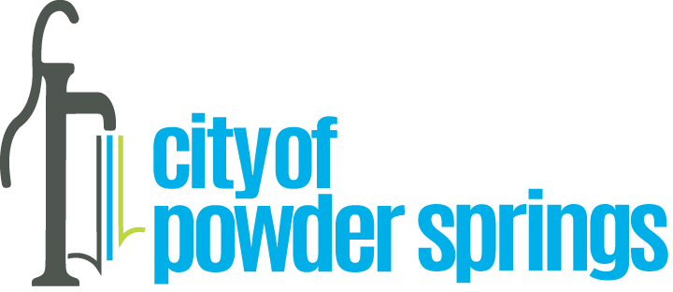

Proclamation
In Recognition of Small Business Week

WHEREAS, The City of Powder Springs recognizes and values the dedication and entrepreneurial spirit within our community; and
WHEREAS, small businesses are the backbone of Georgia’s economy; and
WHEREAS, small businesses keep our community, the state and America's economies growing strong; and
WHEREAS, the President of the United States has proclaimed National Small Business Week every year since 1963 to highlight the programs and services available to entrepreneurs through the U.S. Small Business Administration and other government agencies; and
WHEREAS, the City of Powder Springs supports and joins in this national effort to help America's small businesses do what they do best, create jobs, and ensure that our communities remain as vibrant tomorrow as they are today; and.
IT IS THEREFORE PROCLAIMED, by the Mayor and Council for the City of Powder Springs that the City recognizes and celebrates "NATIONAL SMALL BUSINESS WEEK" and reminds its residents of the importance of this community celebration which acknowledges and celebrates the achievements made by small businesses, both locally and nationally.
IN WITNESS WHEREOF, we the Mayor and Council have hereunto set our hand and cause the seal of the City of Powder Springs to be affixed this 6th day of May 2024.

______________________________________
______________________________________
______________________________________
______________________________________
______________________________________
______________________________________

